Carlos Rodriguez

pwn. college Username: Carlos

CSCI 400-01

9/8/25

Lab 3

1. Becoming root with su
   1. 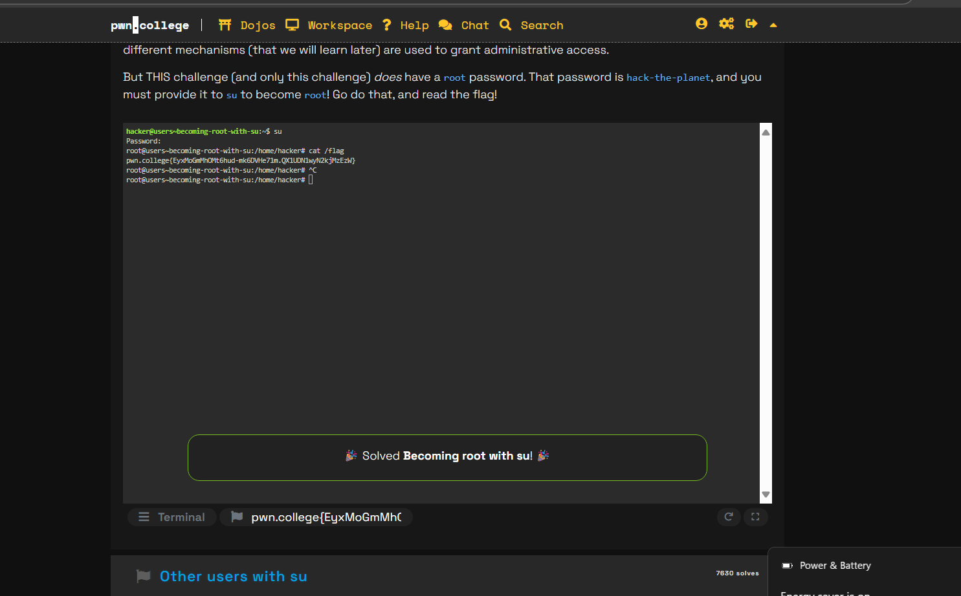
2. Other Users with su
   1. 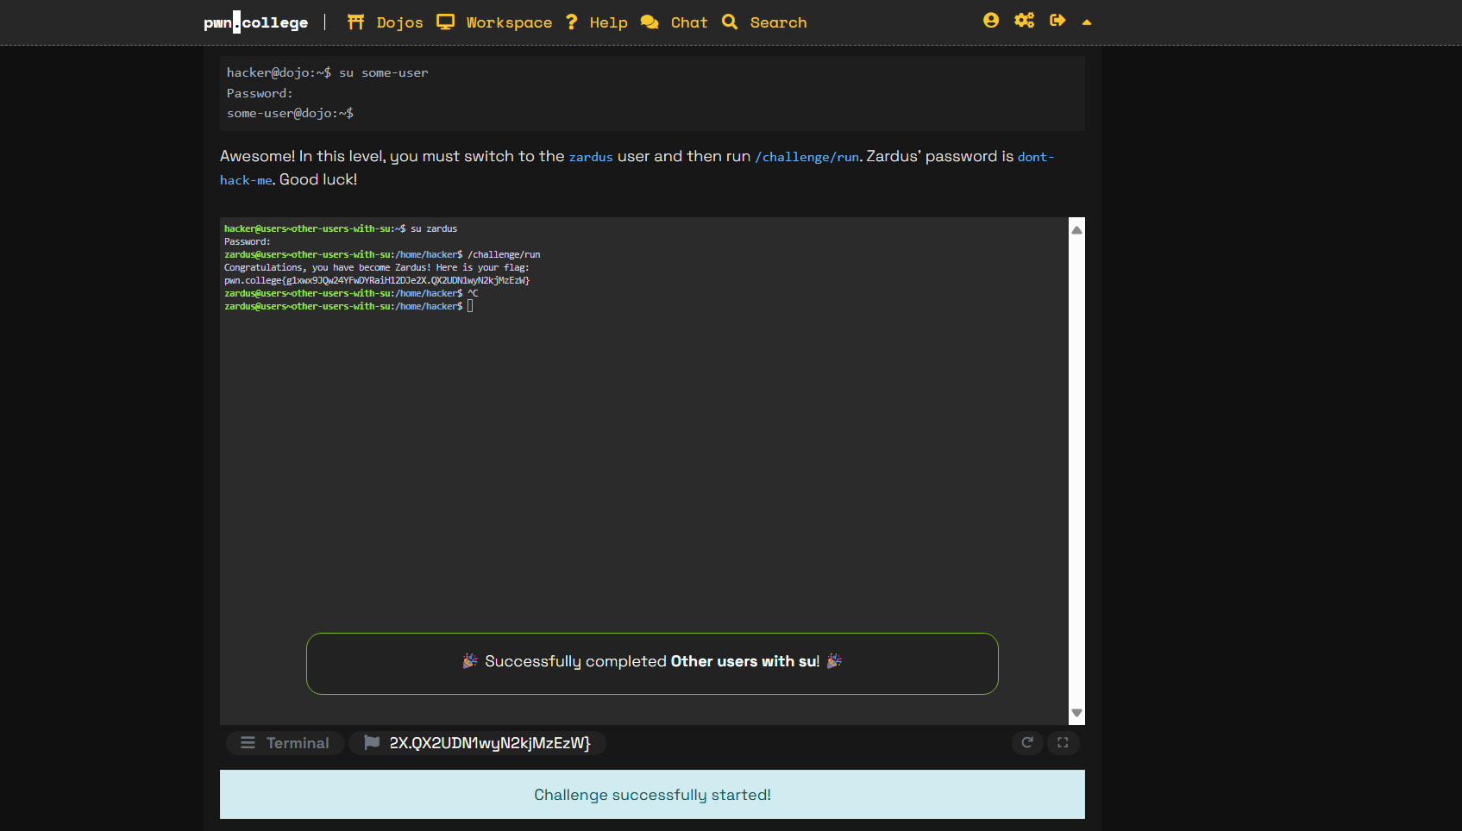
3. Cracking Passwords
   1. 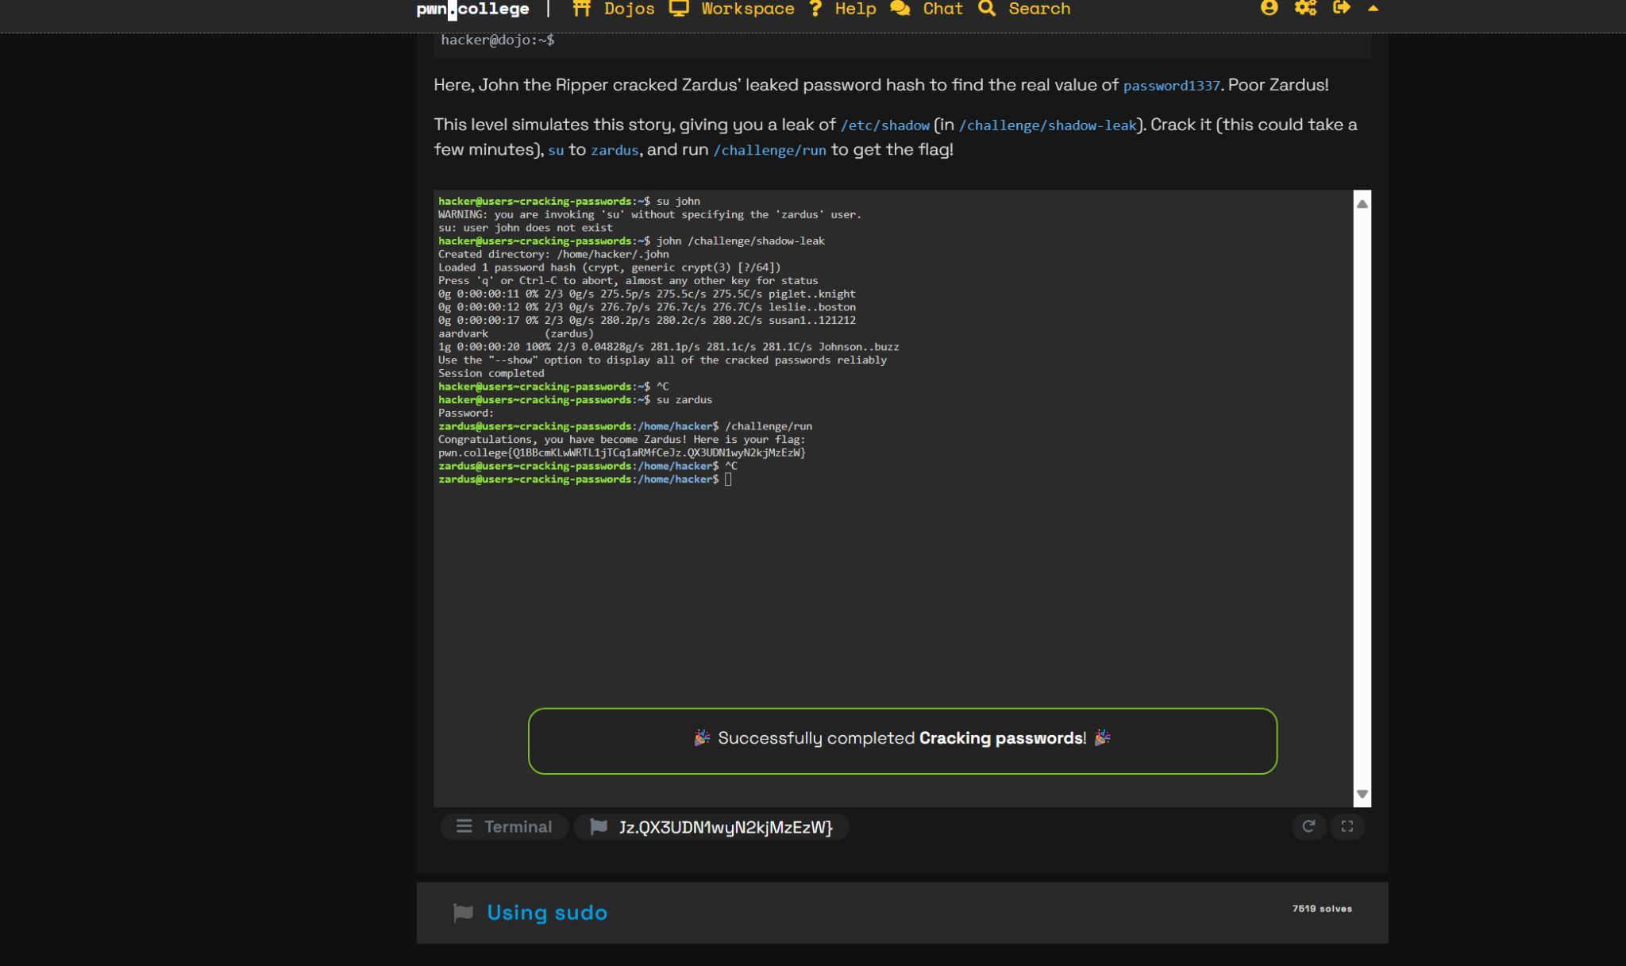
4. Using Sudo
   1. 